PRESS RELEASE
DATE: November 16, 2021
AUTO RETAIL BUY-SELL ACTIVITY AT RECORD LEVELS
Haig Partners released its Q3 2021 Haig Report, the leading industry quarterly report that tracks trends in auto retail and their impact on dealership values. Highlights include a significant spike in dealership profits and skyrocketing demand from dealership groups that want to acquire more stores. These trends have driven record-shattering blue sky values for dealerships. To learn more about findings from the Q3 2021 Haig Report, register for the live Q&A with Alan Haig taking place Thursday, November 18th at 1:00pm ET.
Key findings from the Q3 2021 Haig Report include:
- The Chipdemic continues to create extraordinarily favorable conditions in auto retail
- Dealership profits are erupting with the average privately-owned dealership making $3.4M (excluding PPP) over the twelve-month period ending September 2021
- Buy-sell activity is at record levels, reaching 575 this year, a 24% increase over the previous record of 463 in 2015
- Blue sky values continue to shatter records, rising to an estimated 61% from the end of 2019
- Public company spending on US auto acquisitions may reach $8B by year end 2021, 10x pre-Pandemic levels
- Public equity valuations are 108% higher than they were before the Chipdemic
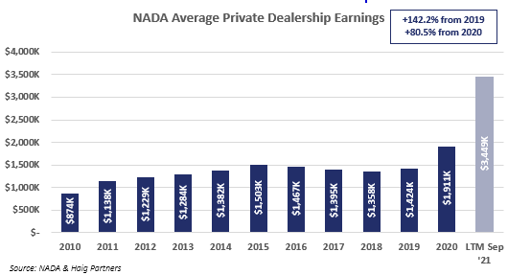
“We are seeing plenty of dealers come to market to sell their stores. Profits are high, dealer confidence is high and interest rates remain low,” shared Alan Haig. “The high value for stores today is stimulating dealers to consider exiting even if they are not at retirement age. Average single point dealerships are worth about $25M all-in. Midsized groups are valued in the hundreds of millions of dollars. Large groups bring billions of dollars. At these values, dealers and their families are having conversations about the pros of remaining dealers, but also the risks and capital investments required if they remain dealers. We expect 2022 to be another excellent year for transactions,” he continued.
For more findings from the Q3 2021 Haig Report, download it here. In addition, Alan Haig will be sharing current trends in auto retail and their impact on dealership values, during a live Q&A session on Thursday, November 18that 1:00 pm ET. Register for the event at HaigPartners.com.
Haig Partners is hearing from many dealers who want to seize what appears to be a once-in-a-lifetime opportunity to sell at record high prices. If you are interested in buying or selling a dealership or would like to have a confidential conversation, contact Alan Haig directly at (954) 646-8921.
About The Haig Report
The Haig Report, published quarterly, includes data and analysis on the performance of auto dealerships, discusses noteworthy events impacting the industry, identifies trends in the M&A market for dealerships, provides guidance on estimated value ranges for different franchises, and shares an outlook for the M&A market. The Haig Report is based on data gathered from reputable public sources, as well as interviews with leading dealer groups and dealers, bankers, lawyers, and accountants who specialize in auto retail.
About Haig Partners
Haig Partners LLC is the leading buy-sell advisor to owners of higher value retail dealerships. The team at Haig Partners has represented 19 of the Top 150 dealership groups on the Automotive News Top 150 list, more than any other buy-sell firm in automotive retail. Since 1996, they have advised on over 280 dealership transactions, comprised of more than 540 dealerships totaling $8 billion. Haig Partners has unmatched auto retail experience with backgrounds in executive leadership and corporate development roles for AutoNation, Asbury, Bank of America’s Dealer Financial Services team and DHG’s Dealership Practice. Haig Partners authors the leading industry quarterly report that tracks trends in auto retail and how they impact dealership values, and are co-author of NADA’s Guide, “Buying and Selling a Dealership.” For more information, visit www.haigpartners.com.
Press Contact:
Aimee Allen
Haig Partners
Director of Marketing and Business Development
aimee@haigpartners.com

